BÁO CÁO THỰC HÀNH LAP 2

LẬP TRÌNH HƯỚNG ĐỐI TƯỢNG

1. UML & Astah
2. Problem Statement of AIMS Project

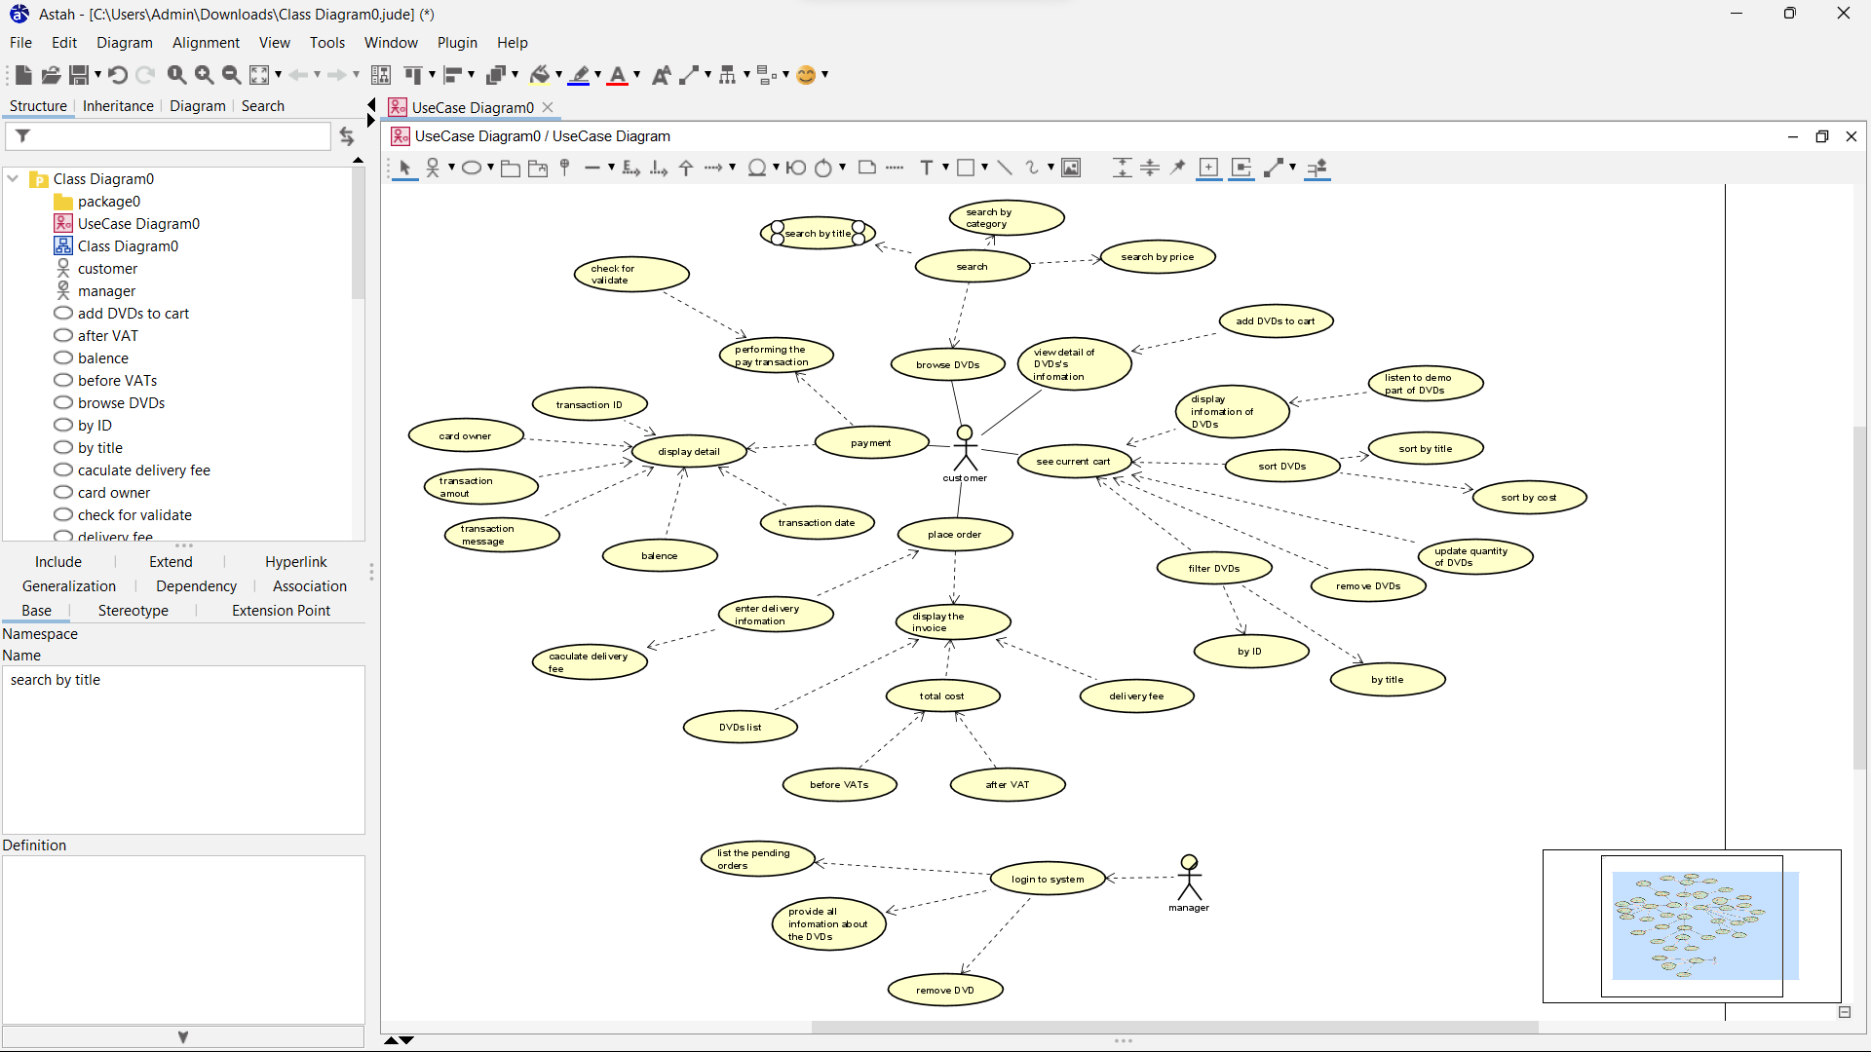

1. Create Aims class

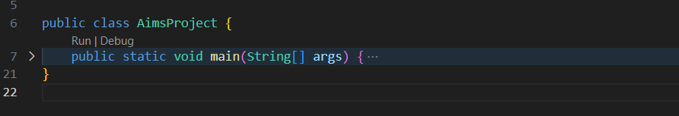

1. Create the DigitalVideoDisc class and its attributes

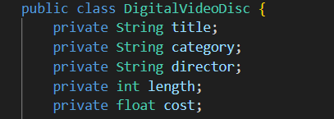

1. Create accessors and mutators for the class DigitalVideoDisc

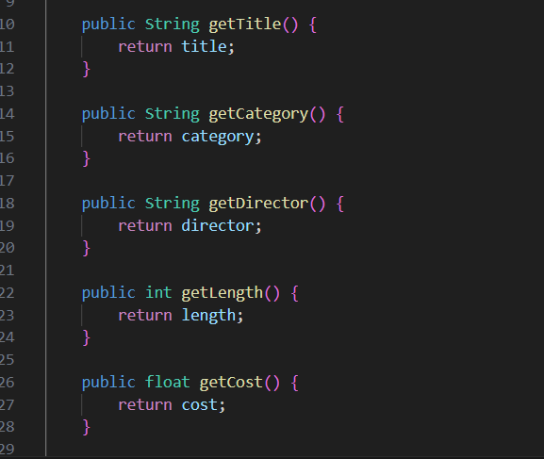

1. Create Constructor method

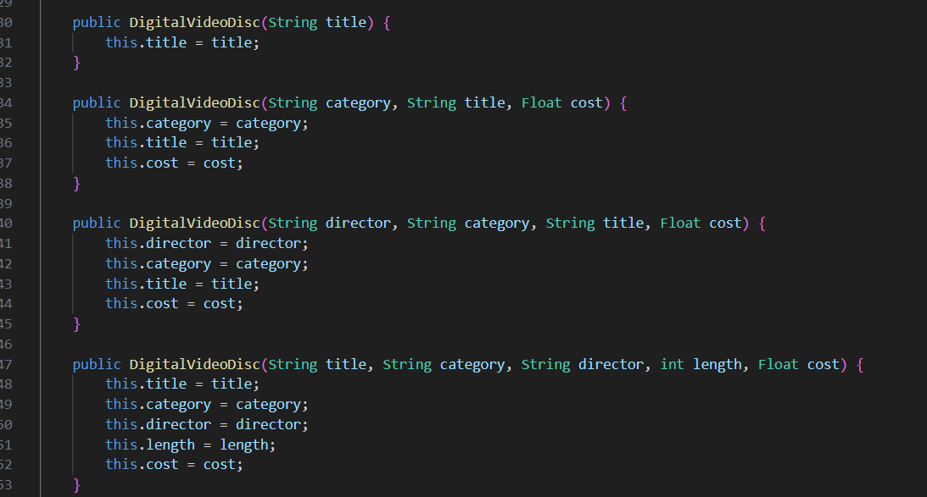

1. Create the Cart class to work with DigitalVideoDisc

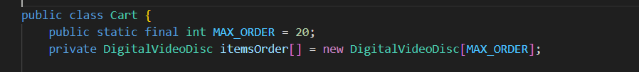

1. Create Carts of DigitalVideoDiscs

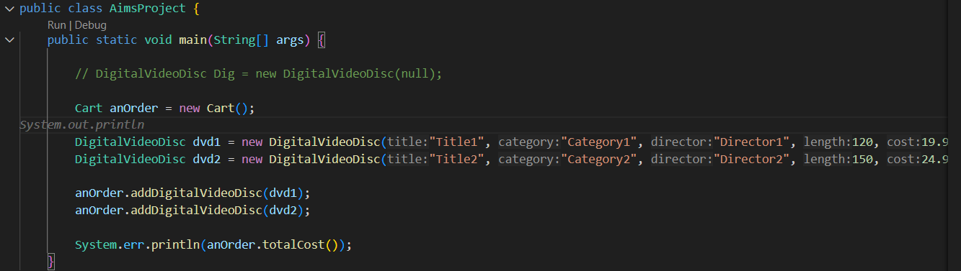

1. Removing items from the cart

